ENG4C1
Photo Story 3 Assignment

You can use Photo Story 3 for Windows to create visually compelling and fun stories using your pictures, music, and narration.

Using the image of an immigrant’s shoe in the dust as the story “spark”, create a photo story on the topic you researched in the Resource Centre.

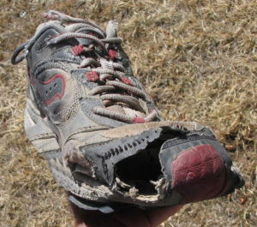
http://i98.photobucket.com/albums/l280/goobergabbles/old-sneakers-031106.jpg

Components for the story: the story must include cited photos (on a separate sheet), captions for the photos (where appropriate), copyright free music, and narration (citations on a separate sheet) on the topic your group researched.

Story length: no longer than 4 minutes.

Instructions for using Photo Story 3

- Double click on DeskTools.

- Find the icon Photo Story 3 for Windows, and double click on it.

- On the Welcome page, click Begin a new story, and then click Next.

Importing and arranging your pictures

First, add the pictures that you want to use in the story, and then arrange them in the order that they will be viewed.

- On the Import and arrange your pictures page, click Import Pictures.

- In the File Browser dialog box, browse to My Documents\My Pictures.

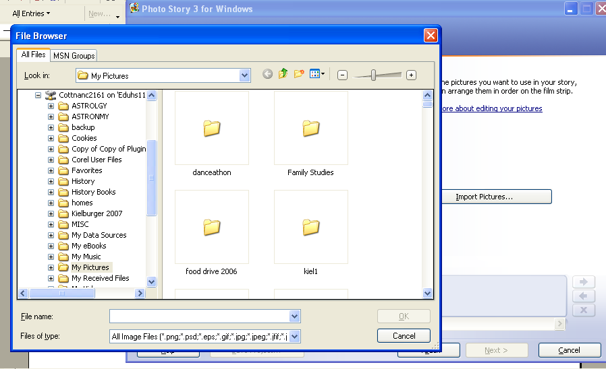

- Add any pictures you have saved so far.

- To add more than one picture at a time, press and hold the CTRL key and click on the pictures you want to add, and then click OK.

- All of your pictures should now be present in the filmstrip.
The filmstrip in Photo Story is a great place to quickly make changes to your pictures and story. For example, you can drag a picture in the filmstrip to change the sequence. You can click a picture in the filmstrip and click Edit to change the appearance of the picture by rotating it, adjusting the colour, fixing red eye or adding effects. You can also right click a picture to perform these actions. Try adding an effect to one of the pictures to see what they look like.

- Click on Save Project before continuing. Give your story a meaningful name. Your story will automatically be saved in the My Videos folder with the file name extension of .wp3 You can go back and edit this file later, if you wish.

- When you have finished making changes to your pictures, click Next to continue.

Adding a title to your pictures

- On the Add a title to your pictures page, click the first picture, and then type your title in the text box to the right of the picture.

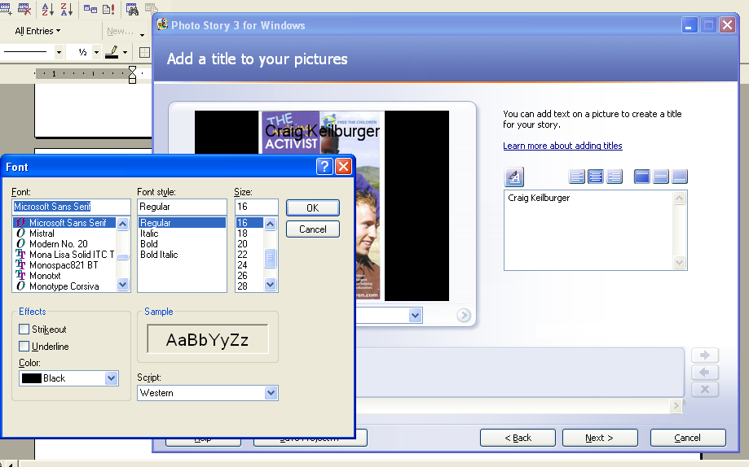

- Click the Select Font button.

- In the Font dialog box, you can change the font, font style (i.e. bold, italic etc.), size, colour.

- Click the Align buttons to align the title to the left, center, right, top, middle or bottom of the picture.

- When you are finished adding text, click Next.

Adding Customized motion and Transition

You can add custom pan and zoom effects and transition and motion to your story to add interest.

- Click on the Customize motion button.

- Select the beginning position of the motion and the end position. Click Preview to see the path. This feature will simulate movement and make your story more interesting.

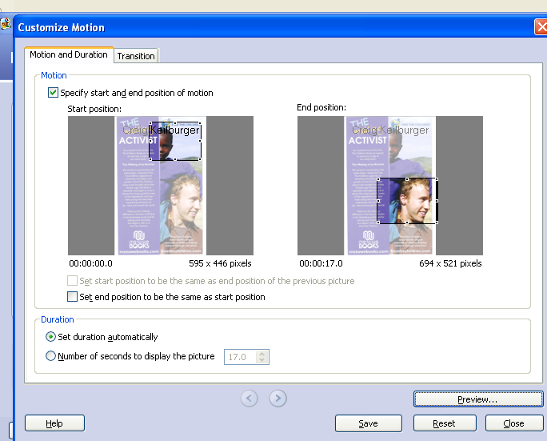
Start position
End position

- Click on the Transition tab. Choose one of the transitions available. Click Save.

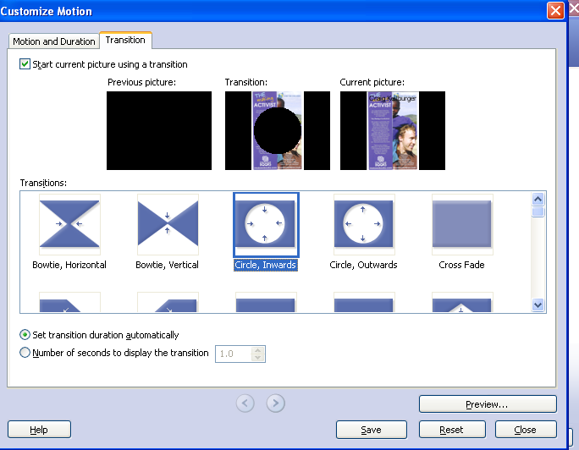
Narrating your pictures

You can add narration to your photo story to make it more unique and personal.

To add narration to your story you need to have a working microphone attached to your computer and set up correctly.

On the Narrate your pictures and customize motion page,

- Click a picture on the filmstrip.

- Add any desired text in the cue card area.

- Click the Record Narration 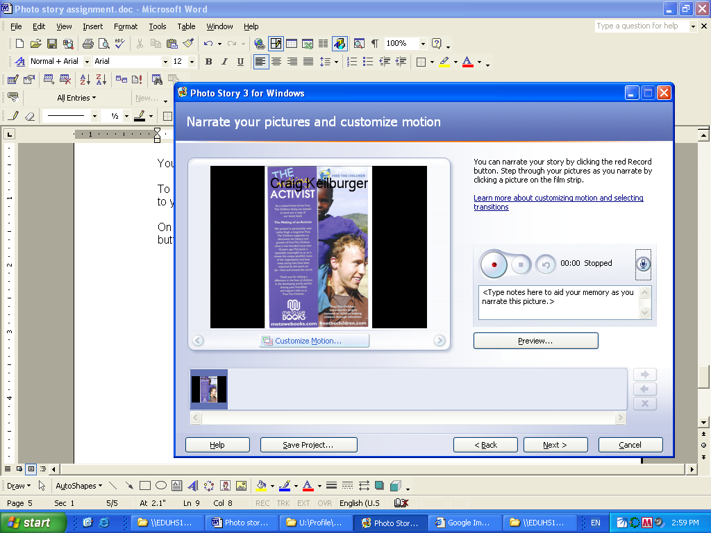 button to start recording narration.
The red dot in the record button will flash indicating recording is taking place. A timer is provided to help you keep track of your narration length.
- When you have finished narrating the picture, click the Stop Recording button.

- Repeat steps 2 thru 4 for each picture for which you want to add narration.

Note: Narration for each picture cannot exceed 5 minutes

- Once you have added narration, click the first picture in the filmstrip, and then click Preview to see how your story looks and sounds.

- Close the preview window and click Next to continue to the next step.

Adding background music

Any music you add to your story must be copyright free. You may not use any downloaded music files from the Internet. You can select music from the M: drive or create your own music. Both options will be explained below.

Select music

- On the Add background music page, click on a picture that does not have any narration.

- Click Select Music.

- On the File Open dialog box, click the Multimedia …[M:] drive location.

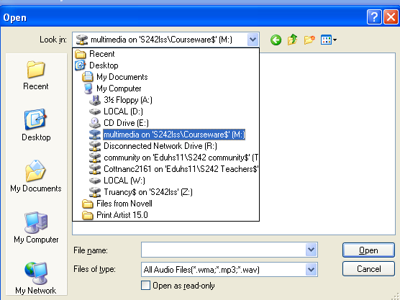

- Click on the Music folder, then click Open.

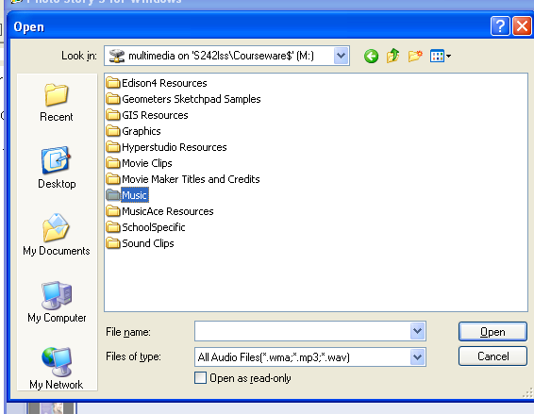

- Open a folder that looks promising from the choices provided.
- Once the music is added, it is shown as a coloured bar above the picture in the filmstrip. This helps you determine which pictures will be shown for each piece of music you add. This is particularly helpful when you add more than one song to your story. Click on Preview to hear your music selection.

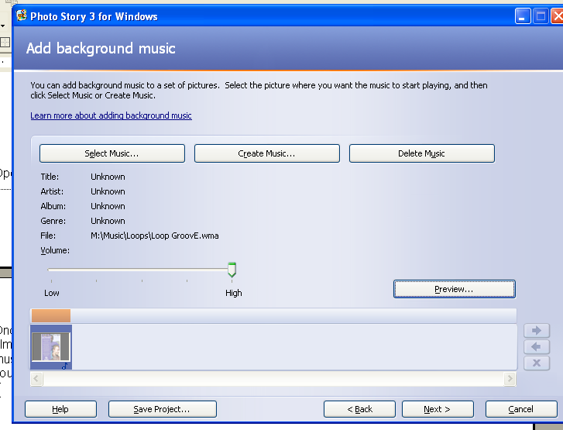
Coloured bar
Click here to hear your music

Create music

- Click on another picture in your filmstrip.

- Click Create Music.

- In the Create Music dialog box, in the Genre drop-down list, scroll down and select your choice. Select the style. Click OK.

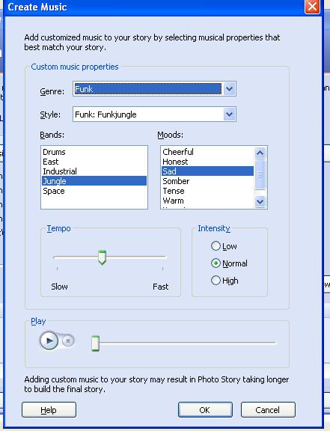

- Click on Preview to see and hear how your story looks so far.

- Click Next.

Saving your photo story

When you save your photo story, all the pictures, narrations, and music are complied into a video file that you can view in Windows Media Player.

- Click on the first option Save your story for playback on your computer.

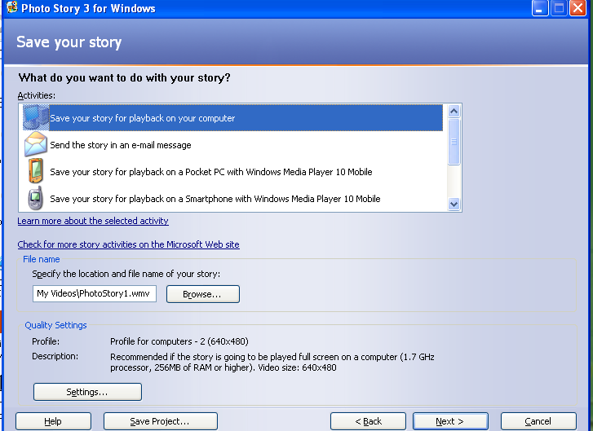

- Leave the location to save the story in My Videos.

- Click on Next.

- If you are asked if you want to save the story in a project for future editing, click Yes. (You may not be asked this question if you saved your story as a project at the beginning of this exercise).

- Click Exit

